**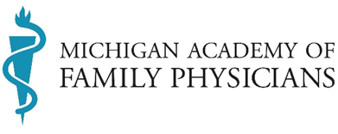  
ANNUAL MEETING AGENDA**

**July 15, 2024 ● 11:45 am – 1:45 pm   
The Grand Hotel, Mackinac Island, MI**

|  |  |  |
| --- | --- | --- |
| Welcome and Call to Order | **Brandon Karmo, DO, FAAFP Speaker** | **10 minutes** |
| AAFP Degree of Fellow Convocation | Steven Furr, MD, FAAFP AAFP President | **10 minutes** |
| 2024 Award Winner Recognition | Steven Furr, MD, FAAFP AAFP President | **9 minutes** |
| MAFP Initiatives and Operations | Karlene Ketola, MSA, CAE Chief Executive Officer | **5 minutes** |
| Official Business ● Resolutions  ● 2024-2025 Board Slate of Nominees | **Brandon Karmo, DO, FAAFP Speaker** | **50 minutes** |
| Installation of the Board of Directors | Steven Furr, MD, FAAFP AAFP President | **15 minutes** |
| Outgoing Presidential Address | **Beena Nagappala, MD, MPH, FAAFP President** | **10 minutes** |
| Incoming Presidential Statement | Rachel Klamo, DO, MS, FAAFP **President-elect** | **10 minutes** |
| Adjournment | **Brandon Karmo, DO, FAAFP Speaker** | **1 minute** |

**About MAFP**

Michigan Academy of Family Physicians is a state chapter of American Academy of Family Physicians. MAFP serves Michigan’s family medicine physicians, residents and students through advocacy, practice support and creating community and connections for all members. MAFP's membership totals more than 4,300 individuals, making us the largest medical specialty association in the state.